AI ASSISTED CODING LAB ASSIGNMENT 3.1
Name:K.Meghana
HTNO:2303A52345
Batch:44
Question1: Zero-Shot Prompting (Palindrome Number Program)
Prompt:Generate a Python function that checks whether a given number is a palindrome.
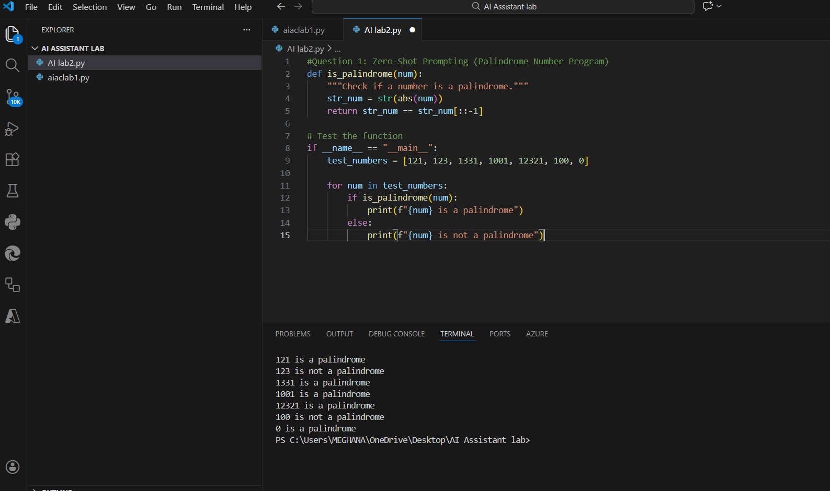
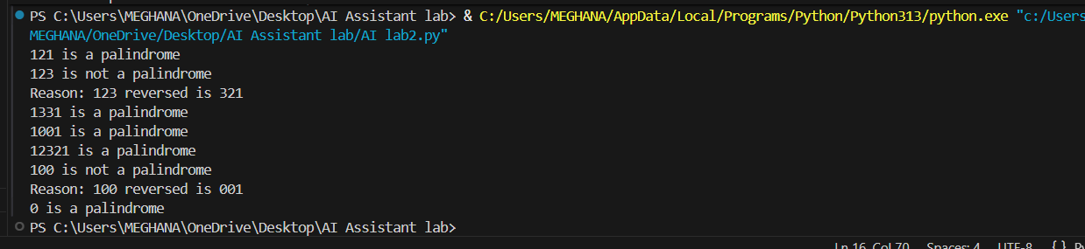
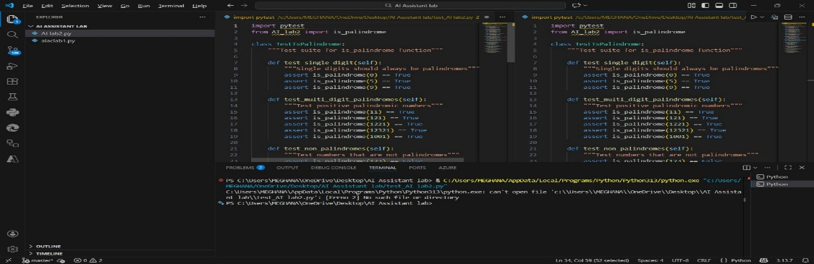
explanation:
1. The function takes a number as input to check whether it is a palindrome.
2. The number is converted into a string for easy comparison.
3. The string is reversed using slicing.
4. The original string is compared with the reversed string.
5. The program prints whether the number is a palindrome or not based on the comparison.

Input:[121, 123, 1331, 1001, 12321, 100, 0]
Output: 121 is a palindrome
123 is not a palindrome
1331 is a palindrome
1001 is a palindrome
12321 is a palindrome
100 is not a palindrome
0 is a palindrome
Question2: One-Shot Prompting (Factorial Calculation)
Prompt: generate a Python function to compute the factorial of a given number.
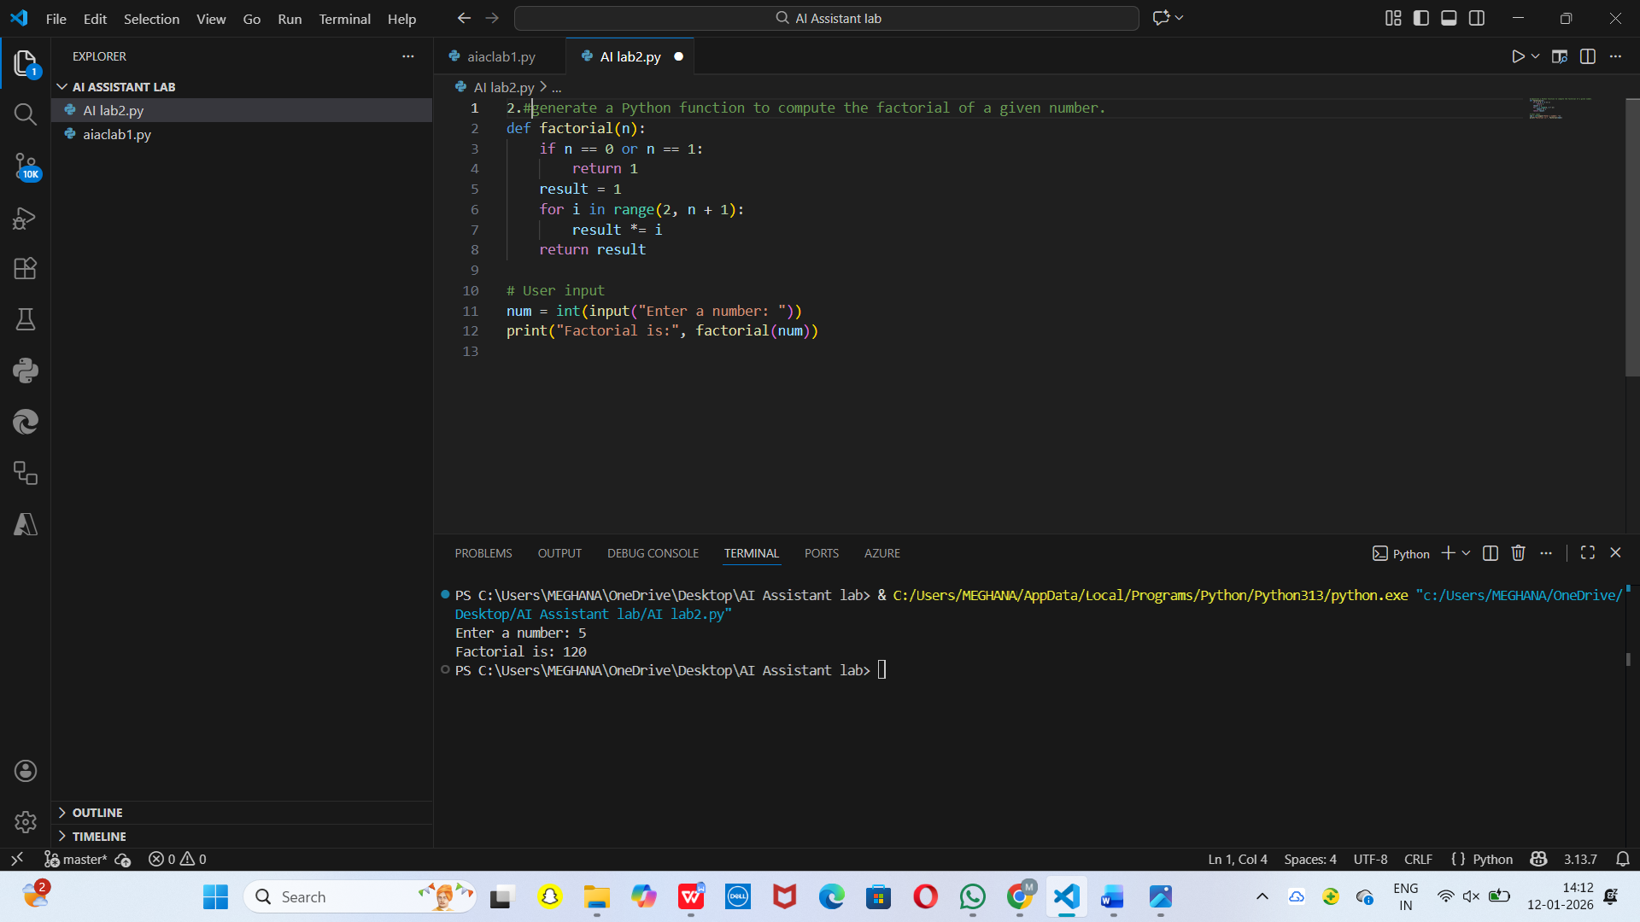
Explanation:
1.The function factorial(n) calculates the factorial of a given number.
2.If the input is 0 or 1, the function returns 1.
3.A loop multiplies numbers from 2 to n.
4.The user enters a number using the input() function.
5.The program prints the factorial of the entered number.
Input:Enter a number: 5
Output: Factorial is: 120
Question3: Few-Shot Prompting (Armstrong Number Check)
Prompt: generating a Python function to check whether a given number is an Armstrong number.
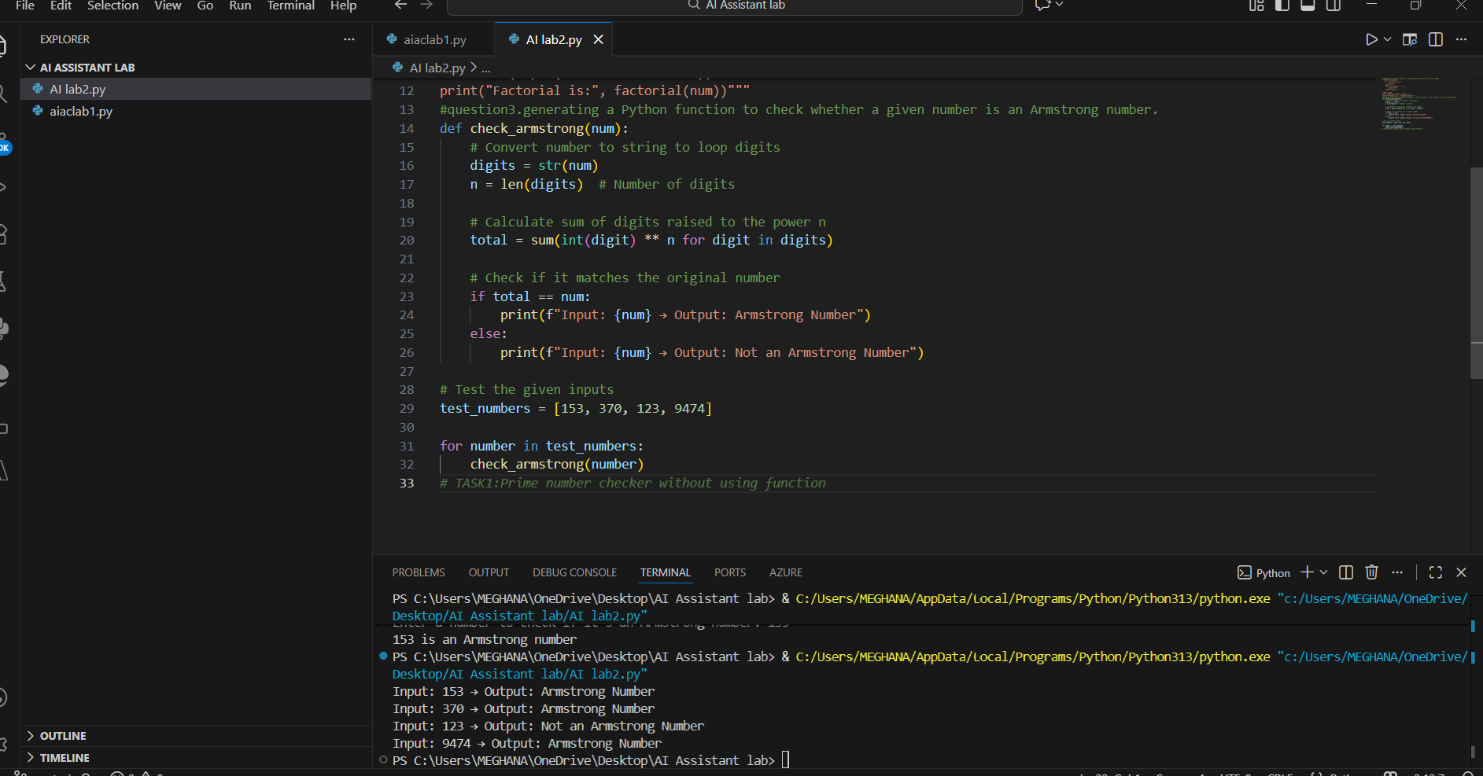
explanation:
1. For each number, break it into digits.
2. Raise each digit to the power of number of digits.
3. Add them together.
4. If the sum equals the original number → "Armstrong Number".
5. If not → "Not an Armstrong Number".
Input: 153 → Output: Armstrong Number
Input: 370 → Output: Armstrong Number
Input: 123 → Output: Not an Armstrong Number
Input: 9474 → Output: Armstrong Number
Question 4: Context-Managed Prompting (Optimized Number Classification)
Prompt: generate an optimized Python program that classifies a number as prime, composite, or neither.
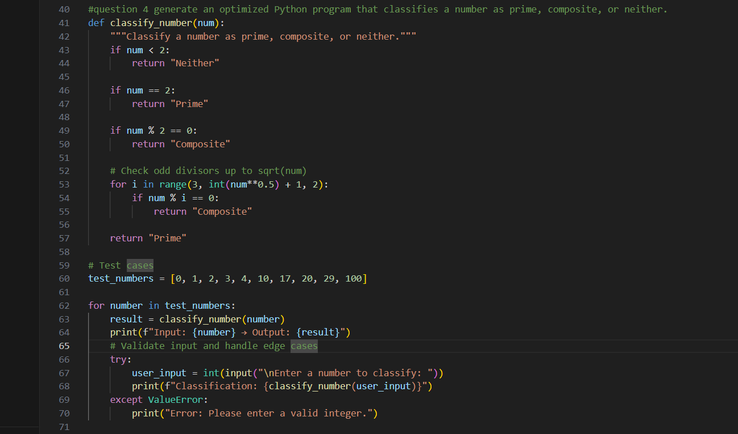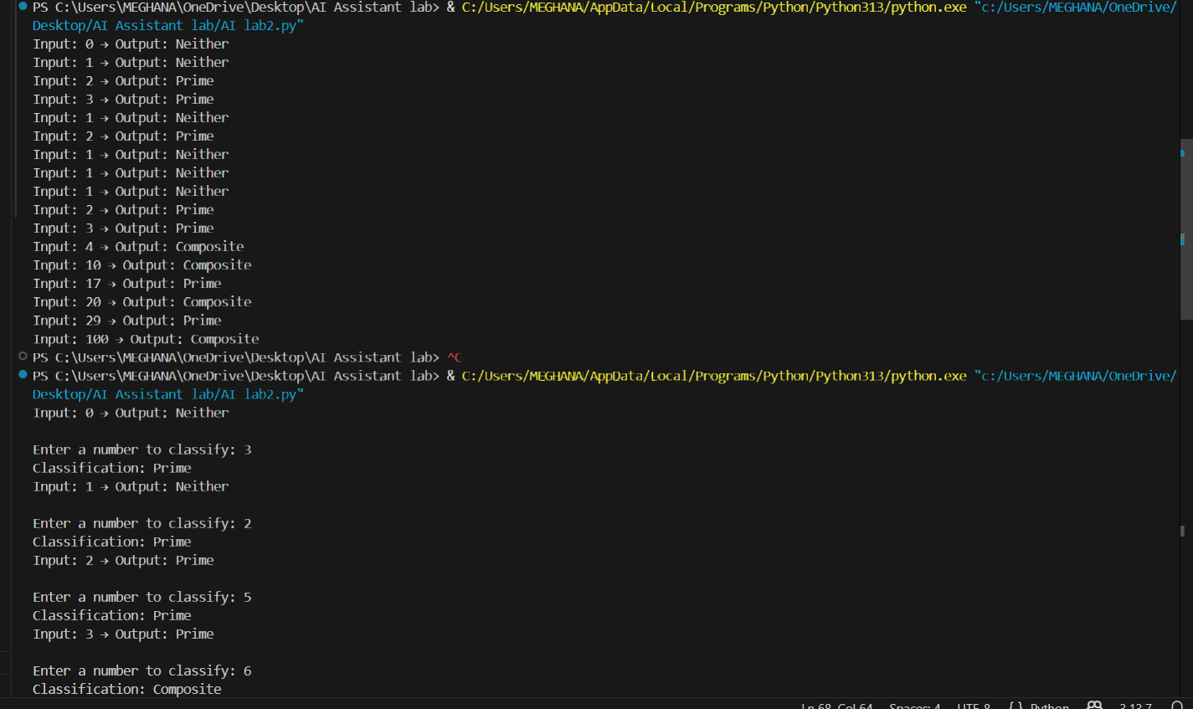
explanation:
1. Input Validation:Ensures only integers are processed and prints "Invalid input" for invalid types.
2.Handling Special Cases:
Numbers less than 2 → "Neither prime nor composite".
Number 2 → "Prime" immediately.
Even numbers >2 → "Composite" immediately.
3.Optimized Prime Check:Checks only odd divisors up to √n, reducing unnecessary calculations.
Improves performance for large numbers compared to checking all numbers.
4.Clear Output Format:Prints results as "Input: <number> → Output: <classification>" for readability.
5. Efficiency and Robustness:
Early returns stop computation as soon as the classification is known.
Handles edge cases, negative numbers, zero, and large numbers efficiently.
Question 5: Zero-Shot Prompting (Perfect Number Check)
Prompt: generate a Python function that checks whether a given number is a perfect number.
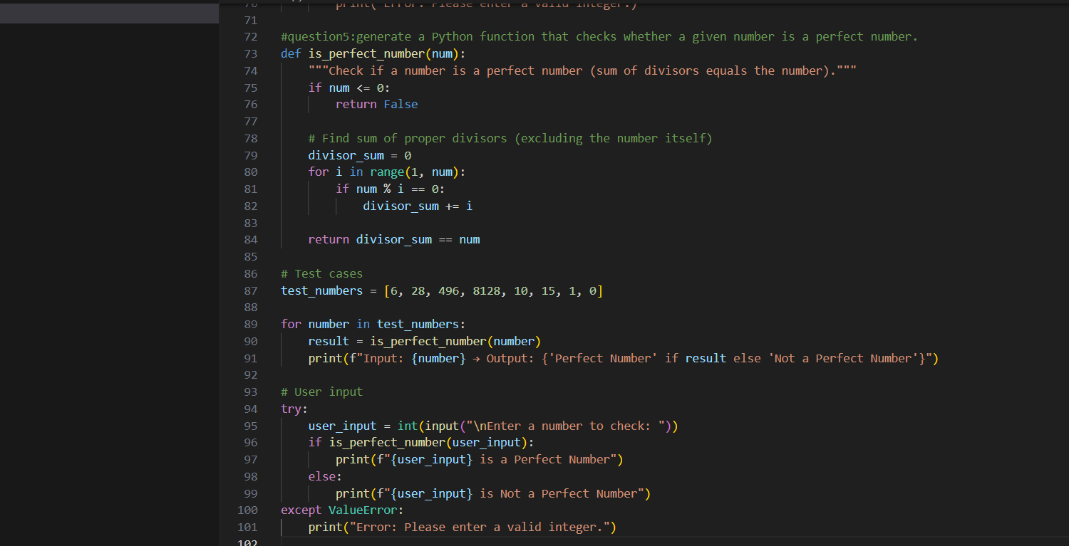

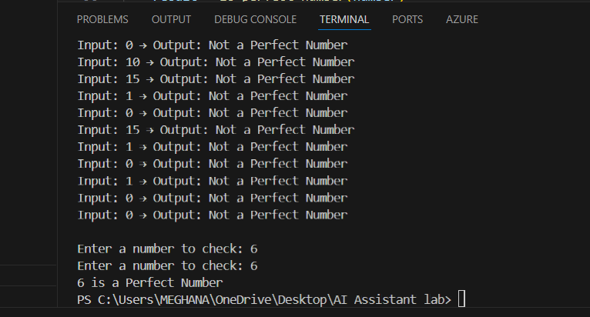
Explanation:
1. A perfect number is a number equal to the sum of its divisors except itself.
- Example: 6 → 1 + 2 + 3 = 6
2.The program checks if a number is perfect or not.
3. First, it makes sure the number is positive and an integer.
4. Then, it finds all divisors of the number except itself.
5. It adds the divisors and compares the sum with the original number.
6. If the sum = number → it’s a Perfect Number; if not → Not a Perfect Number.
7. For optimization, we only need to check divisors up to half of the number.
8.The program also handles invalid inputs like 0, negative numbers, or letters.
Input | Output
6-> | Perfect Number
28-> | Perfect Number
12-> | Not a Perfect Number
496-> | Perfect Number
0-> | Invalid input
-5 -> | Invalid input
"abc" | ->Invalid input
Question 6: Few-Shot Prompting (Even or Odd Classification with Validation)
Prompt: generating a Python program that determines whether a given number is even or odd, including proper input validation.
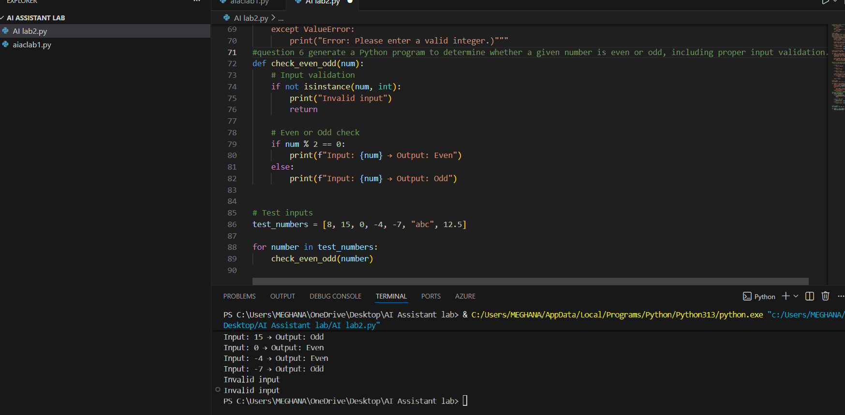
Explanation:
1.The program checks whether a number is Even or Odd.
2. It validates the input to ensure it is an integer.
3. Even if num % 2 == 0, otherwise Odd.
4. Handles zero and negative numbers correctly.
5. Prints “Invalid input” for non-integer inputs.
Input: 8 → Output: Even
Input: 15 → Output: Odd
Input: 0 → Output: Even

